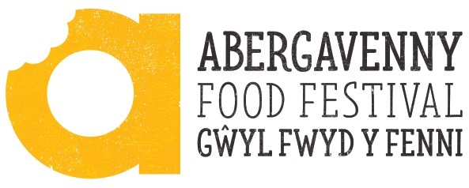

Fringe Programme Submission Form

Please return your completed form to lotti@abergavennyfoodfestival.com by Friday 12th May. This is our final deadline for print materials. If we receive your form any later than this date we cannot guarantee your inclusion in the printed programme. We recommend that you return your form to us at the earliest opportunity.

Event title
Date of event
Time of event
Venue (please provide full address, including postcode)
Name of organisation
Contact name
Contact number
Contact email
Your website address
Your Twitter handle
Your Facebook page
Your Instagram handle

Picture & Logo
Please send us a high res version of your logo, and high res imagery that best represents your venue or event.

We will use your photography online and in print, so please aim to send us a selection of good quality, preferably landscape photography, and please ensure you have permission to share these images with us.
Details for the programme
Event description
Max 100 words (min 50 words). This will be used in our event programme and online so please ensure it is concise, informative and spell checked!

Booking
How many people do you think will attend your event?
How will people register for your event?
If you are selling tickets, how many tickets will be available for sale?
How much will tickets cost?
Will you be selling your tickets through the Abergavenny Food Festival ticket sales service? |  |  | Yes /No
If no, please detail how you intend to sell tickets

If yes, please provide us with your bank details. Abergavenny Food Festival will send the proceeds of ticket sales to you within 30 days of the end of the festival, minus a 7% commission. |  |  | Name
 |  |  | Bank
 |  |  | Account No.
 |  |  | Sort Code
Promotion
How will you promote your event in addition to publicity provided by Abergavenny Food Festival?

Stories
If you have a story or angle which you think may be of interest, please detail with corresponding contact details.

Feedback
How will you record your event? Will you be taking photos/video? Will you be collecting visitor feedback?

Legacy
What lasting change will this make in your area? How will you continue to drive the message of good food after your event has finished?
Insurance
Do you have the necessary insurances to run this event? Please detail your public liability insurance provider or let us know if you need help in putting forward an application.

Health & Safety
Do you or will you have a risk assessment in place? Have you registered your event with the local authority? Do you have an up to date Health Hygiene Certificate if you will be handling food? Have your appliances been corgi/PAT tested? Have you considered your crowd management plan? Please detail
Office use only – please do not fill in

Theme
Target Audience
Children | Young people | 18-24 |  | 65+ |  | All Ages | Other

